PROJECT 4::

1.USE-CASE DIAGRAM Debit card:

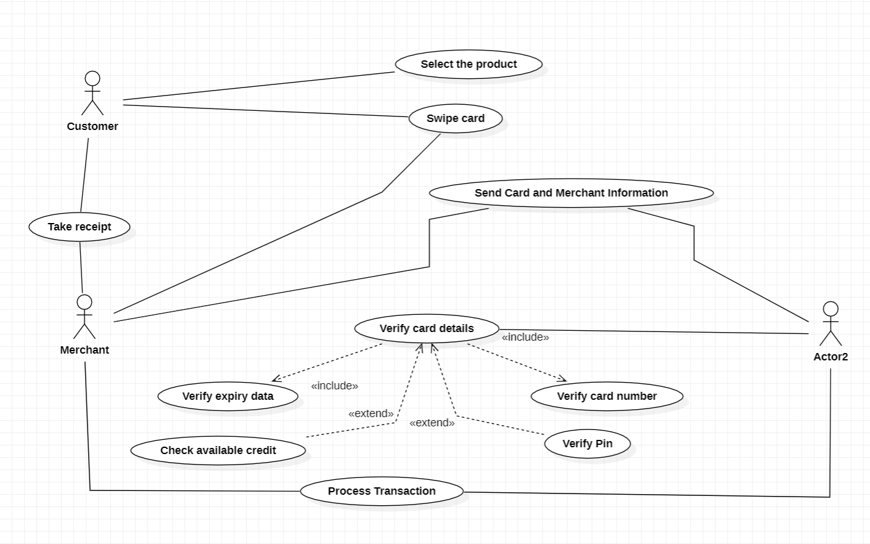

2.USE-CASE DIAGRAM Debit card:

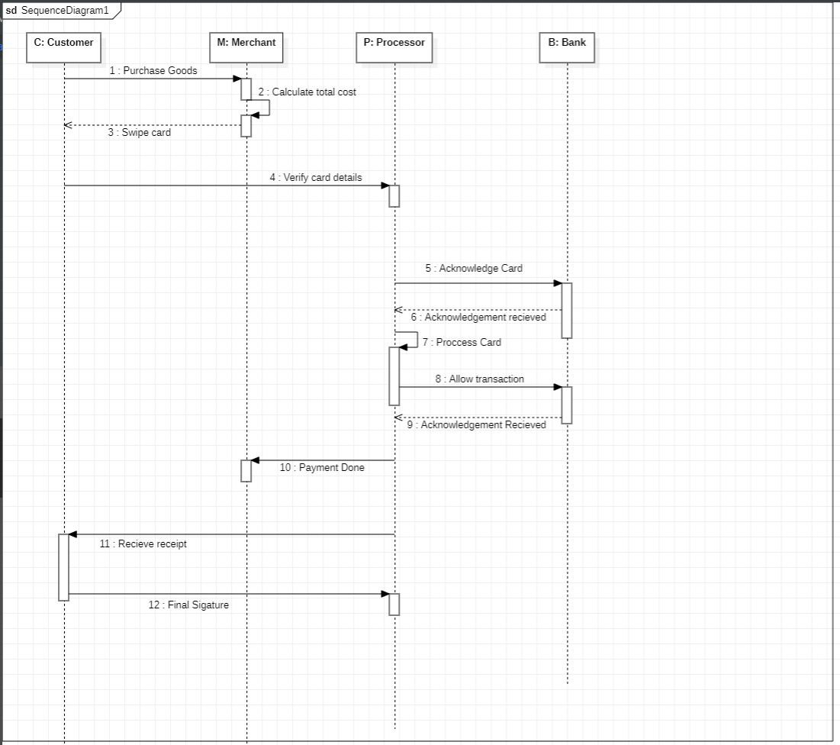

3.Collaboration Diagram Debit card:

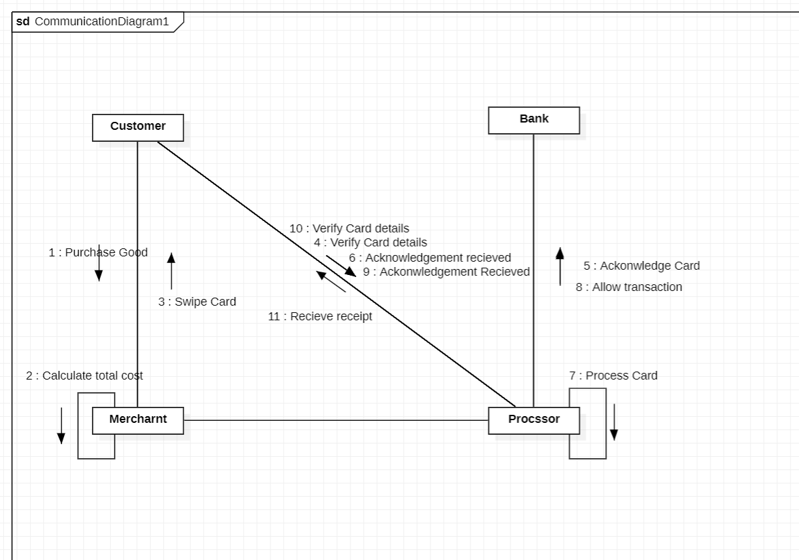

4.Activity Diagram Debit card:

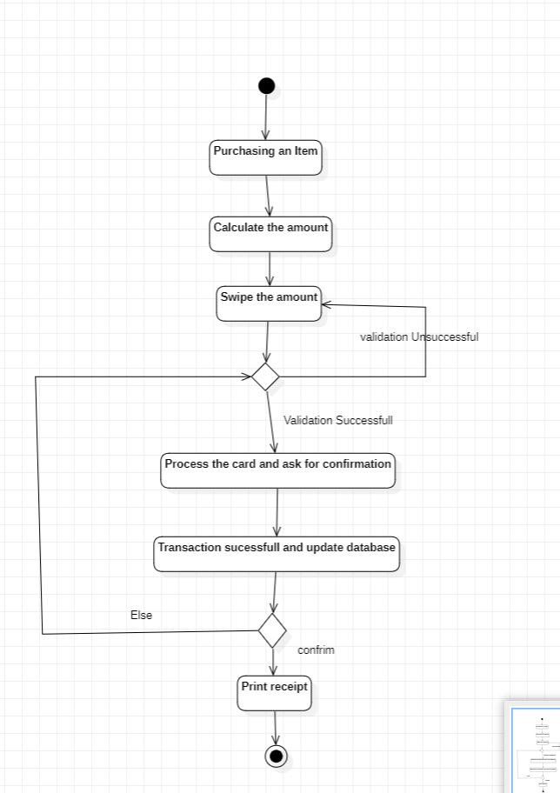

5.Deployment Debit card:

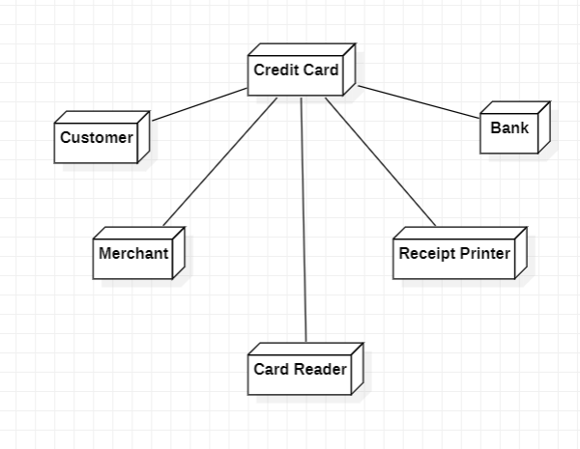

6.Class Debit card:

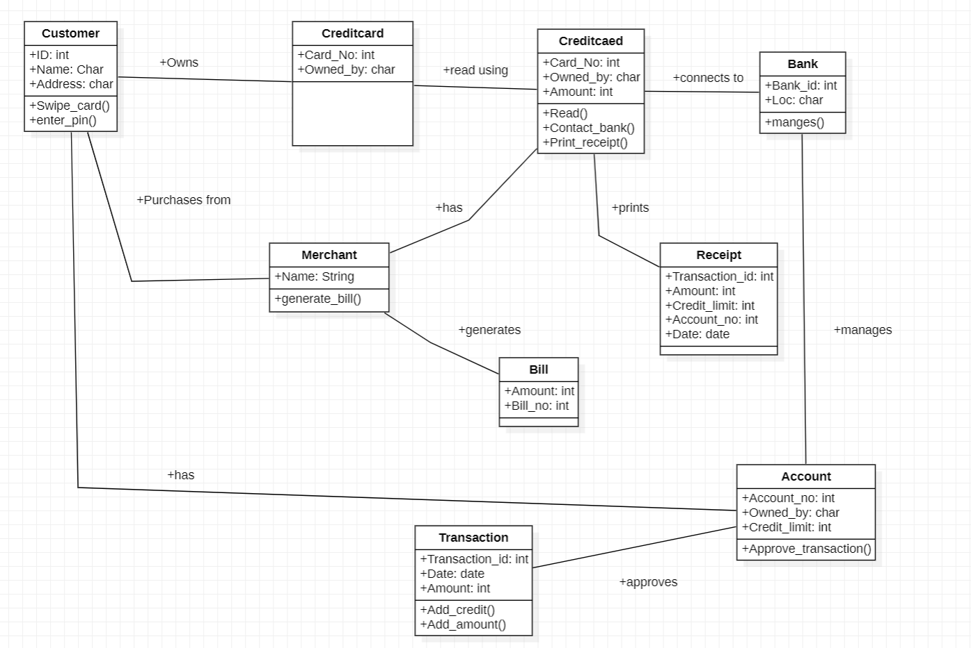

7. Component Debit card:

